**Ngunnawal Cultural Research**

Joshua O’Regan

**Population Data of The Ngunnawal Region**

The population of Canberra today, the primary territory in the Ngunnawal region is approximately 462,000, representing a rough 1% annual growth of the population from previous years.

In contrast to the Ngunnawal people, the traditional custodians of the land we live on today only saw a populous ranging between 1,000 and 2,000 people. This represents a 462-231% increase in population between the traditional aboriginal peoples and today's Ngunnawal country.

**Language Spoken**

Burragorang language is the native tongue of the Ngunnawal people, however, their dialect varies slightly to the Gundungurra peoples who speak the same language with a varied dialect.

Below is a table of keywords in the Ngunnawal dialect translated to English:

| **English** | **Ngunnawal** |
| --- | --- |
| Boy | Bubal |
| Girl | Mullaŋan |
| Sun | Winyu |
| Moon | Kubbadaŋ |
| Clouds | Gurraŋ |
| Day | Bural |
| Night | Kagu |

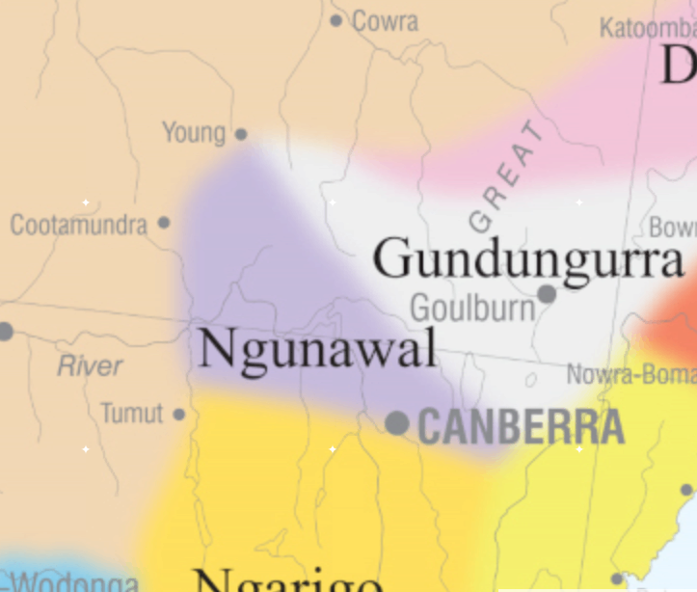**Ngunnawal Location**

The Ngunnawal Territory is a triangular region encompassing Canberra and bordering on Young, Cootamundra and Tumut and neighbouring Goulburn to the north.

**Historical Environment**

It is said that the Ngunnawal region was particularly taxing on the aboriginal peoples due to the harsh climate; Hot summers, cold winters. Survival required great knowledge of the region due to the mountainous terrain, calling for cooperation from the group in order to survive the unique environment the Ngunnawal region presented before them. With this being said, the mountainous region that the Ngunnawal people inhabited was home to a variety of flora and fauna that the aboriginal people utilized for survival, everything from building materials to medicine was provided by the land.

**Current Environment**

Canberra today is an interesting mix of industrial, residential, bush and city whilst avoiding overcrowding like much of Australia's other big cities. The annual rainfall peaks in April averaging 63.7 mm of rain and is at its lowest in June with an average of 32.5 mm. The average temperatures peak towards the end/beginning of the year particularly in January (average high 29°C, Low 14°C) and it’s the lowest temperature being in July (average high 11°C, Low 0°C) however it is not all that uncommon for temperatures to reach upward of 40°C, and as low as -5°C. The bush surrounding Canberra is quite dense which in combination with the rocky terrain makes it difficult to traverse, if the terrain now is in anyway resemblant to the land the Ngunnawal people once walked on, it is understandable as to why it was vital for the Ngunnawal people to have a deep understanding of their environment in order to make a living.

**Traditional Medicines**

As the Ngunnawal people lacked the technology available to us today and the subsequent breakthroughs in the medicinal field, they were entirely dependent on the environment for their survival, a big part of which is being able to treat ailments and injuries. People of the Ngunnawal clan were quite fortunate in this area however as the mountainous terrain of Ngunnawal harboured many natural remedies, below is a table of traditional aboriginal medicines and their uses:

| **Name** | **Usage** |
| --- | --- |
| (Cauliflower Plant/Bush) Cassinina longifolia | The leaves are used as plasters (band-aids) to seal cuts, preventing infection and healing the wound. |
| (False Sarsaparilla) Hardenbergia violacea | The flowers were crushed, turned into a mouthwash and gargled in order to treat ulcers as well as utilized to treat chest infections. |
| (Apple Box) Eucalyptus bridgesiana | The leaves were infused in water and then the vapours would be inhaled to aid with colds. |
| (Soap Bush (Blackwood)) Acacia melanoxylon | The leaves were crushed and mixed with water to make an antibacterial soap. |

**Traditional Bush Tucker**

Just as important as the medicine was the fuel required to keep them going. The Ngunnawal territory is plentiful in animals and plants that the traditional Ngunnawal peoples utilized in order to ensure that they did not go hungry and could function throughout the day. Below is a Table of traditional Ngunnawal bush tucker and how it was prepared.

| **Name** | **Usage** |
| --- | --- |
| (Kangaroo Apple) Solanum linearifolium | The berries are picked and eaten |
| (Malaburk) Banksia marginata | The flowers are soaked in water to give a natural energy drink |
| (Kurrajong) Brachychiton populners | The seeds are cooked yielding food similar to popcorn. |
| (Bullrush/Bush Rice) Scirpus spp. | The seeds are taken and cooked like rice while the fruit is harvested once it has turned a red/orange, this typically takes place towards the end of the year (November/December). |

**Conclusion**

The Ngunnawal people survived here for thousands of years, over time developing their language, skills and knowledge that were passed down from generation to generation. knowledge of the land and its environment, natural remedies for their ailments and injuries as well as bush tucker, what was and wasn’t safe to eat; these and more were vital skills not only to survive but also are of great cultural significance to the aboriginal people even today.

**Reference List**

ACT Government. (2021 August 13). *Welcome to Ngunnawal Country*. Ngunnawal Country. <https://www.act.gov.au/ngunnawal-country>

The Australian Institute of Aboriginal and Torres Strait Islander Studies. (2021 August 13). *Living Languages*. Living Languages. <https://aiatsis.gov.au/explore/living-languages>

NSW Government. (n.d.). *Vines* [PDF]. Vines, https://archive.lls.nsw.gov.au/__data/assets/pdf_file/0011/495749/archive-vines.pdf

Merz, S.K. Sinclair Knight Merz. (1996). *Map of Indigenous Australia* [Map]. Retrieved August 13, 2021, from <https://aiatsis.gov.au/explore/map-indigenous-australia>

Macrotrends LLC. (2021 August 13). *Canberra, Australia Metro Area Population 1950-2021*. Population. <https://www.macrotrends.net/cities/206175/canberra/population>

World Population Review. (2021 August 13). *Canberra Population 2021*. World Population Review. <https://worldpopulationreview.com/world-cities/canberra-population>

Jones, A. Forkword Plosm. (2014 June 25). *Ngarigo and Ngunnawal word lists*. Forkword Plosm. <https://www.forkword.com/plog/?p=694>

Smith, J. Australian National University. (2009). *Aboriginal Placenames*. ANU Press Library. <http://press-files.anu.edu.au/downloads/press/p17331/html/ch04.xhtml?referer&page=12>

Heaney, E. Australian National University. (2020). *KNOWLEDGE AND USE OF TRADITIONAL PLANTS BY NGUNNAWAL AND YUIN PEOPLE OF AUSTRALIA: BARRIERS TO KNOWLEDGE AND TRANSMISSION*. Lincoln University. <https://journals.lincoln.ac.nz/index.php/mk/article/download/1156/825/>